**CMOS AND VLSI DESIGN**

**A Lab Based Project Report On**

**BCD TO EXCESS 3 CODE CONVERTER**

submitted in partial fulfillment of the award of degree

**BACHELOR OF TECHNOLOGY IN**

**ELECTRONICS AND COMMUNICATIONS ENGINEERING**

**By**

**K.N.L.S.MALATHI(160040419)**

Under the guidance of

**DR.FAZALNOOR BASHA**

**Professor Department of E.C.E**

https://www.kluniversity.in/img/logo9.png

**K L DEEMED TO BE UNIVERSITY**

**Green Fields, VADDESWARAM – 522 502**

**Guntur District, A.P., INDIA.**

**2016 – 17**

**K L DEEMED TO BE UNIVERSITY**

**DEPARTMENT OF ELECTRONICS AND COMMUNICATION ENGINEERING**

https://www.kluniversity.in/img/logo9.png **CERTIFICATE**

This is to certify that the mini project entitled **“BCD TO EXCESS 3 CODE CONVERTER ”**, being submitted by **K.A.S.K.BHARGAV(160040408)K.PAVAN PRABHU SAI KUMAR (160040420)K.N.L.S.MALATHI(160040419)**in partial fulfillment for the award of degree of **Bachelor of Technology (B.Tech)** in Electronics and Communications Engineering is a record of confide work carried out by them under our guidance during the academic year **2016-2017** and it has been found worthy of acceptance according to the requirements of the university.

**Faculty In Charge Head of the Department DR.FAZALNOORBASHA Dr.V.S.V.PRABHAKAR**

**ACKNOWLEDGEMENTS**

It is great pleasure for me to express my gratitude to our honorable President **Sri. Koneru Satyanarayana**, for giving the opportunity and platform with facilities in accomplishing the project based laboratory report.

I express the sincere gratitude to our principal **Dr.K.SubbaRao** for his administration towards our academic growth.

I express sincere gratitude to our Coordinator **Dr.FazalNoorbasha** his leadership and constant motivation provided in successful completion of our academic semester.

I express my sincere thanks to our project supervisor ­­­­for his novel association of ideas, encouragement, appreciation and intellectual zeal which motivated us to venture this project successfully.

Finally, it is pleased to acknowledge the indebtedness to all those who devoted themselves directly or indirectly to make this project report success.

**CONTENTS**

|  |  |  |
| --- | --- | --- |
| S.NO | INDEX | PG.NO |
| 1 | ABSTRACT | 6 |
| 2 | INTRODUCTION | 7 |
| 3 | CIRCUIT DIAGRAM | 14 |
| 4 | WORKING | 15 |
| 5 | PROCEDURE | 15 |
| 6 | IMPLEMENTED CIRCUIT DIAGRAM | 16 |
| 7 | APPLICATION AND USAGE | 16 |

**ABSTRACT**

In a BCD to Excess-3 code converter it consists of nine possible combinations of BCD inputs namely BO, BI, B2 and B3 respectively. And the output of the design gives the Exccss-3 code namely W, X, Y and Z respectively. The truth table is depicted in below fig. And the circuit diagram of the BCD to Excess-3 code converter is as shown in Fig. and the output logic functions in equations (1.2, 3, 4) 8 × log 2 ⁡ ( 8 ) = 8 × 3 = 24 {\displaystyle \scriptstyle 8\times \log _{2}(8)=8\times 3=24} 888*8

**AIM:**

To implement bcd to excess 3 code

**TOOL REQUIRED:**

Dsch2 and micro wind.

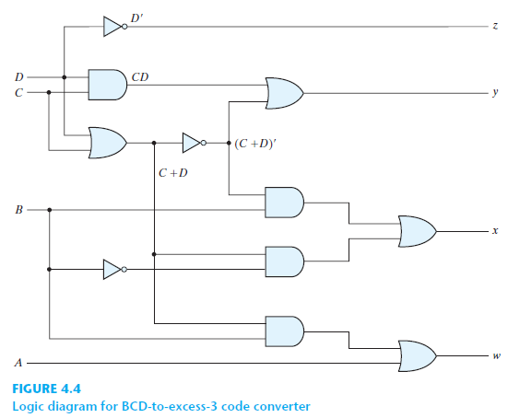

**INTRODUCTION**

**The Excess-3 code:-** It is an important BCD code , is a 4 bit code and used with BCD numbers To convert any decimal numbers into its excess- 3 form ,add 3 to each decimal digit and then convert the sum to a BCD number As weights are not assigned, it is a kind of non weighted codes.

**Binary coded decimal (BCD):-**is a system of writing numerals that assigns a four-digit binary code to each digit 0 through 9 in a decimal (base-10) numeral. The four-bit BCD code for any particular single base-10 digit is its representation in binary notation, as follows: 0 = 0000. 1 = 0001. 2 = 0010.

**CIRCUIT DIAGRAM**

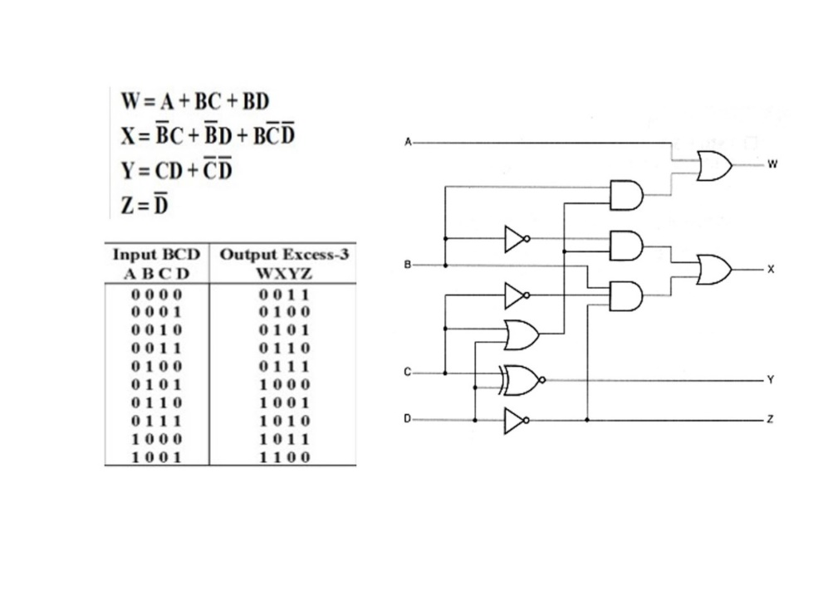

**PROCEDURE IN DSCH2:**

* First open the dsch2 software
* Design the circuit as per the circuit diagram
* Give the inputs and outputs
* Give vdd (source) and vss (ground)
* After completion of designing circuit and then check for output
* At the top of the tool there is a run button click on it and check the output
* For the timing graph at the top there is a icon timing diagram click on it
* Finally, we get an output

**IMPLEMENTED CIRCUIT DIAGRAM IN DSCH2 :**

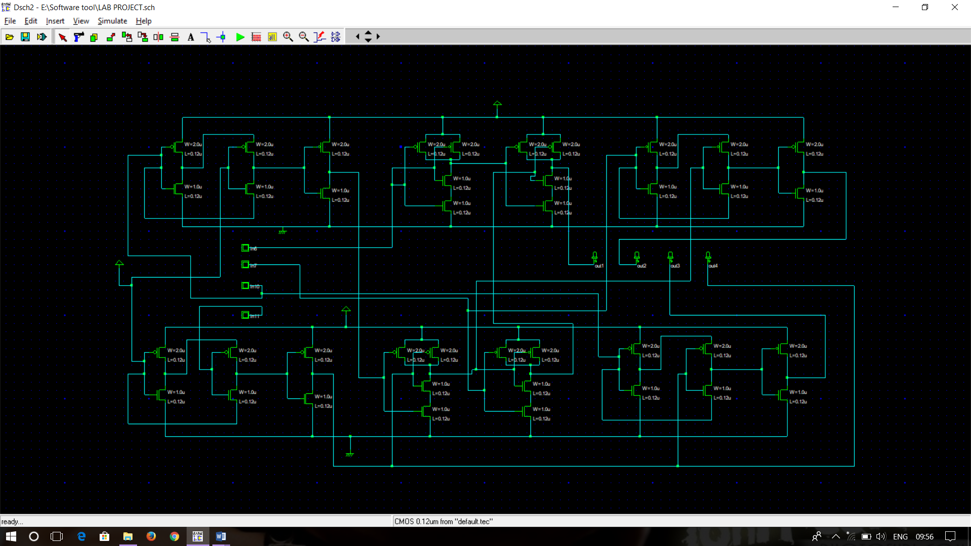

**PROCEDURE IN MICRO WIND:**

* First open the microwind tool
* Select the required pmos and n mos transistors and place it
* Check there is any errors or not if there is any error it will display the error
* At the corner there is clock symbol that is the input place it and also eye symbol is exit that is output place it
* Place the vdd (source) and place vss (ground)
* After completion of designing of circuit, check for output
* At the top there is run button click on it, we get a timing diagram
* Finally, there we can see the output.

**IMPLEMENTED CIRCUIT DIAGRAM IN MICRO WIND:**

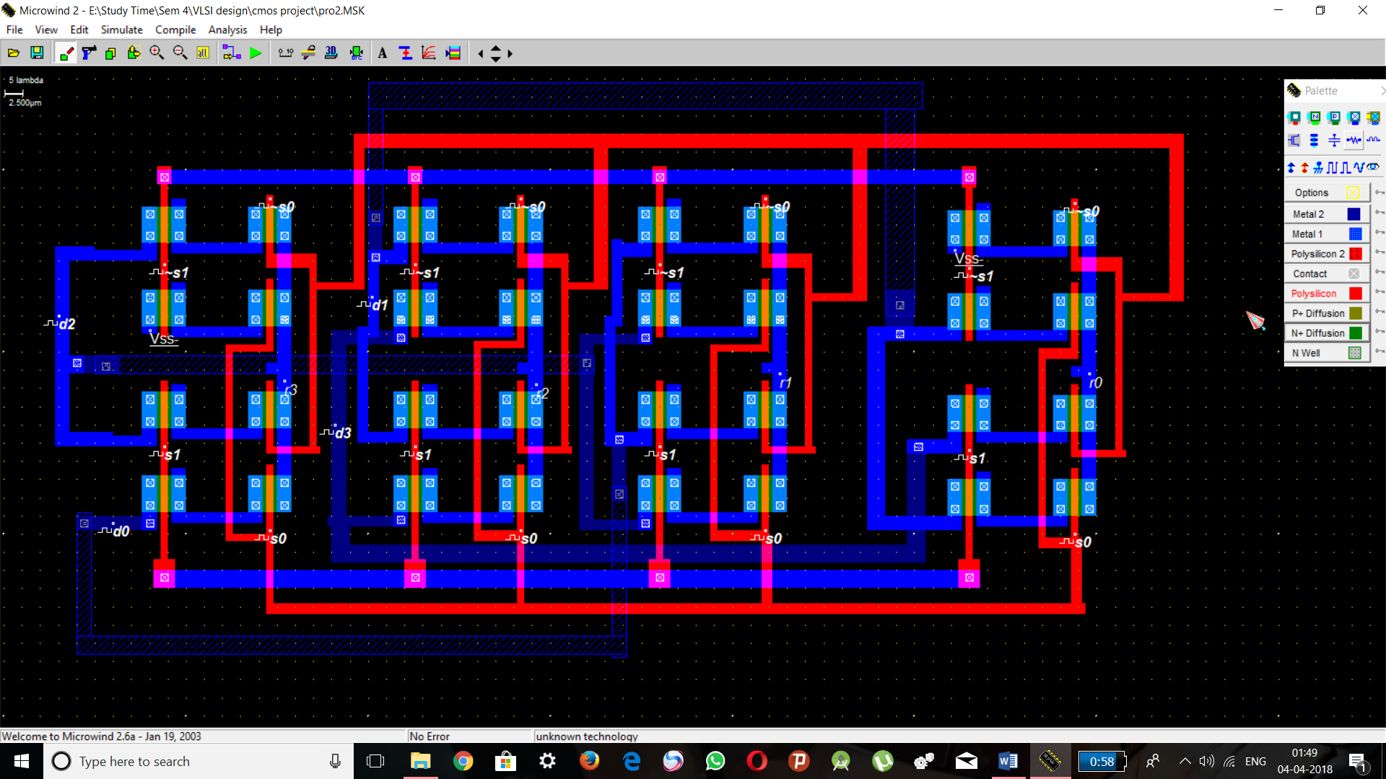

**FEATURES:**

1.BCD is less efficient than binary

2. To encode the same decimal number, bcd needs more number of bits than binary hence bcd is less efficient.

3. BCD arithmetic is more complicated than binary arithmetic.

4.advantage of bcd code is that the conversion from decimal to bcd or vice versa is simple.

**OUTPUTS:**

**IN MICRO WIND:**

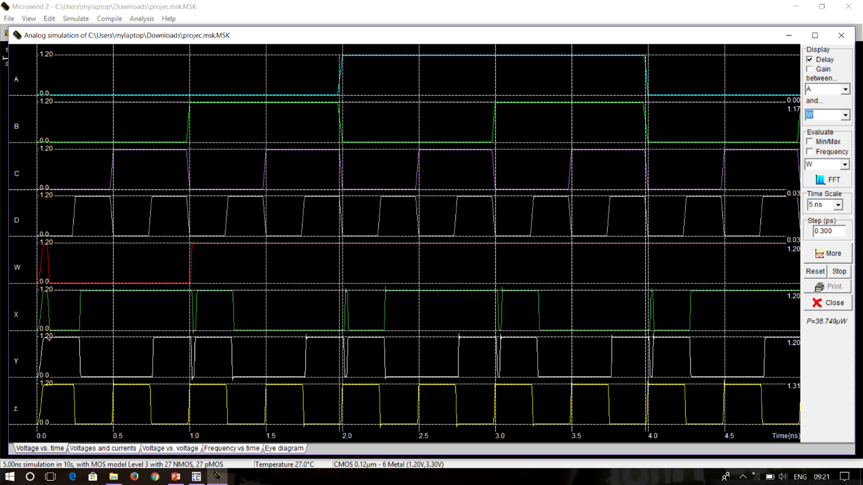

**APPLICATIONS:**

1.) EXCESS 3 WAS USED ON SOME OLDER COMPUTERS.

2.) CASH REGITERS.

3.) HAND HELD PORTABLE ELECTRONIC CALCULATORS.

**CONCLUSION:**

Bcd to excess 3 has been implemented in dsch and microwind and the output is verified successfully.